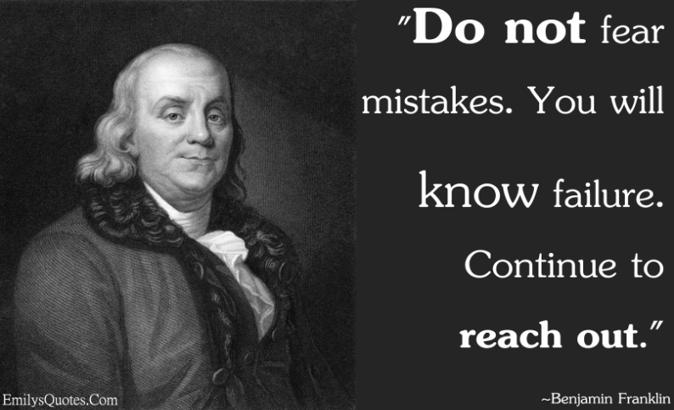
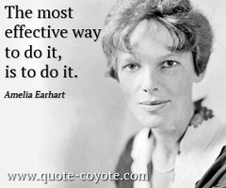
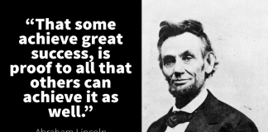
v

Famous Failures
March/April GATE Group
In his book, Mastery, Robert Green claims there are two kinds of failure. There is the negative, no-one-wins, kind of failure and there is a good kind of failure. The negative kind of failure comes from not having the courage to persevere, to “go for it.” You never risk trying out your ideas because of being too afraid, or perfectionistic. There is nothing productive about this kind of failure, and truthfully, this fear-based, perfectionistic type of failure is toxic. You will never learn from this kind of failure. It is self-destructive.
The second kind of failure comes from a bold, gritty, and “can-do” spirit. Even though we’re talking failure, this is “win-win” all the way. If you fail, the blow to your ego is tolerable since the knowledge you have gained from the experience far outweighs the pain of failure. It has been discovered that through repeated failure we toughen our resolve and gain clarity on the correct way to do things. We also build new and stronger neural pathways from our deliberate problem solving.

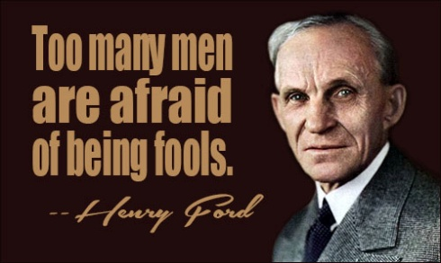
For the next two GATE Group sessions (March and April), our students will be learning about 12 “Famous Failures”, men and women who have overcome obstacles and failures in their lives. And even though these people failed, they turned their failures around as a result of their grit and perseverance.

Our students will have the opportunity to read, as well as watch video clips of these “Famous Failures”, and then each student will create a poster showcasing some of the “grit and perseverance” they learned from these famous people, as well as grit and perseverance they have learned from everyday heroes in their lives.
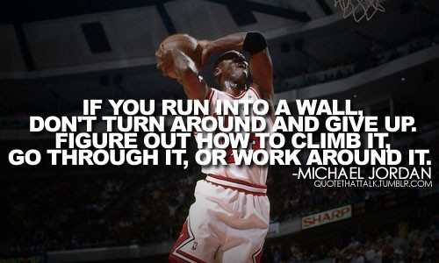
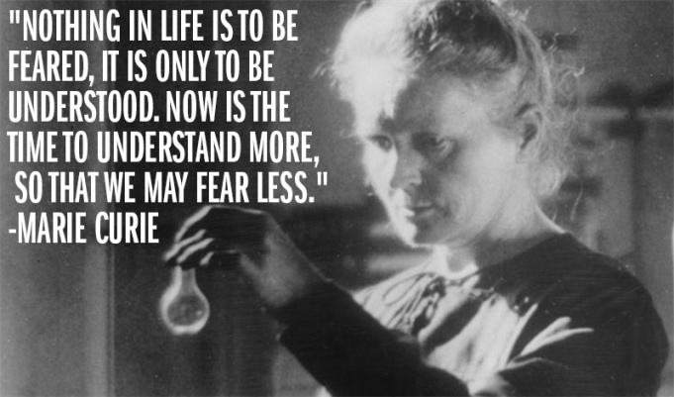
I hope that your children are inspired by this activity, and will also inspire others to have a “can do” attitude!!

